PASTORAL SUPERVISION
JuliAn Heaton
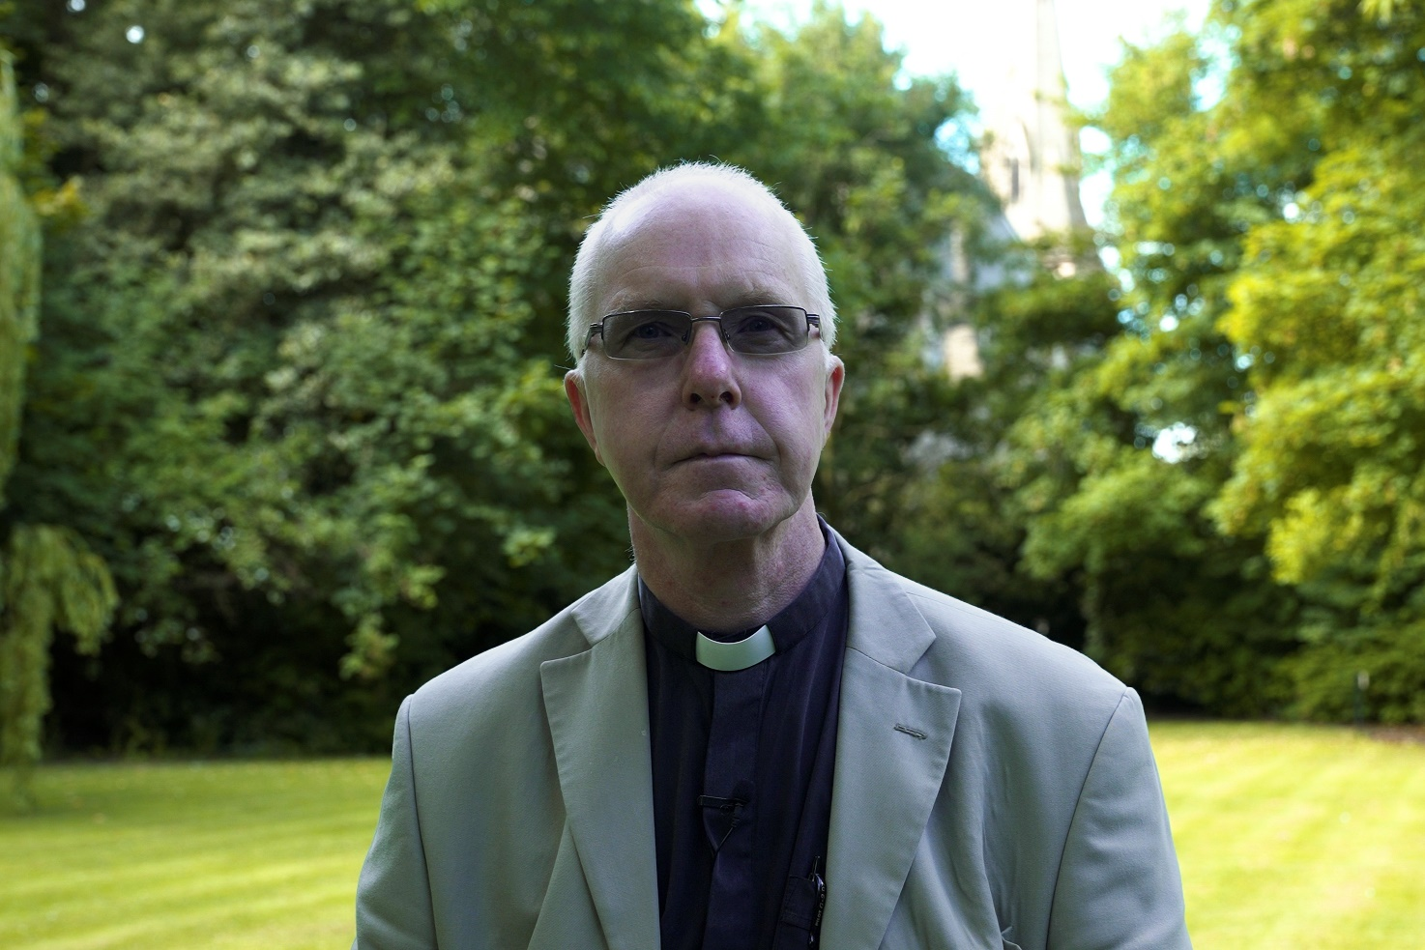

Role and Clergy Background
I am the Rector of Bury Parish Church and Priest-in-charge of St Paul’s, Bury. The former is a classic town centre Civic Church with robed choir and traditional worship. St Paul’s worships in the primary school on a outer housing estate. I have fingers in lots of pies (educational, primary, secondary, as a trustee of an academy and in the town hall. I am also a Mission Community Leader. I have been ordained for 35 years and worked mainly in Chester Diocese (curate, incumbent three times, Assistant DDO, Rural Dean) and as a Full- time Hospital Chaplain in Nottingham. I grew up an Evangelical, trained residentially in a consciously Catholic college for three years, a member of the Society of Catholic Priests, an advocate of holding and valuing the centre-ground of the Anglican tradition in both mission and priestly ministry.

My Supervision
That Chinese curse, ‘May you live in interesting times’ has been lavished on those in ministry. Pastoral Supervision has given me two things. It has given me a framework to look through things that have bothered, frustrated, angered or encouraged me in a way that I have found liberating. My favourite image (if you are old enough to remember) is that often it provides a ‘Heineken moment’, a place of clarity, understanding. It has given me the gift of time. I find we are time-poor. Too busy to do these ‘extra’ things. Commiting to and prioritising supervision has given space to re-centre who I am and what I am called to do. To change practices (do I really need to pander to that person? do those things? stress over that phone call?). The list of things expected of us as clergy seems endless. Supervision has given me, after 35 years, the courage to sit light to some things, to draw closer to others (like setting time aside for my family), made me less cynical and more hopeful. I am grateful for it.

My Approach
We are wandering storytellers. Or analysts of our own stories. Or, possibly, just self-critical junkies. Maybe that’s just me? From my own experience, sitting with someone, sometimes with an urgent story to retell, a desire to make sense of it, to learn from it, sometimes with an amorphous lump of stuff that is disturbing for reasons I cannot fathom, sometimes with a self-loathing of things I have thought or suppressed anger towards someone for some slight. What I have found is that the calm, gentle and open kindness of my supervisor, the probing questions, the careful digging, has allowed both a catching of breath and space and detachment to look afresh as whatever has fizzed around my head. That is what I hope to bring. Yes, there are skills, techniques, and processes which can and do allow an unpacking of the nonsense in our heads. Training has helpfully provided a variety of these so that different personality types can find ways to explore without that grim cringe factor that can lurk and be off-putting for some. The key thing, behind all supervision is the person. And the person I think I offer is reflective, open, interested, curious, concerned for those in ministry, open to learning myself and open to sharing my own learning.

Other Interests
Walking, beer and food (cooking and eating). Family, travel and hens. I read a bit, watch the odd film (cinema, Netflix), go to the theatre regularly. We are sponsors for a family from Ukraine.

