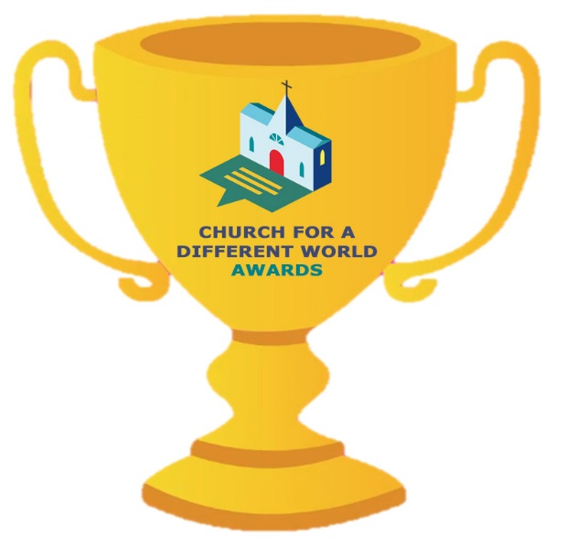**Church for a Different World Digital Awards**

**APPLICATION FORM**

The past two years has seen a digital revolution in our churches. As a result of the pandemic we have seen the growth of online worship and new ways of keeping in touch with people to offer pastoral support and tackle the issue of social isolation. Discipleship groups have met online and churches have reached out to their communities via Facebook, deepening relationships and showing that the church is there for everyone.

Bishop David invites you to apply for a *Church for a Different World Digital Award* this year.

We’d like to hear if you have put extra effort into creating a welcoming and up-to-date website or page on A Church Near You to attract visitors. Have you developed a new online community that values pre-recorded or livestreamed worship? Or perhaps you have nurtured a Facebook or WhatsApp group to connect people who have a common cause. Do you keep people up-to-date by writing a blog or sending out a newsletter? What impact have these had and how might they develop?

Maybe you have recorded your first video or podcast, or used Instagram to connect with your younger church members. Please let us know so we can celebrate and share your success with others.

The *Church for a Different World Awards* encourage us to share our good practice, learn from each other, and celebrate what is good. Your church/chaplaincy is invited to submit an application. The projects which are highly commended will be celebrated, either at a virtual party or a physical gathering at Bishopscourt, if circumstances permit.

Please complete the details below, and describe the work using no more than the next page.

If you wish, you may also submit up to three photographs with your entry (with appropriate permission). Send your completed application to differentworld@manchester.anglican.org or post to the Bishop of Manchester, Bishopscourt, Bury New Road, Salford M7 4LE.

The closing date for applications is 15 **July 2022.**

**Name of Church, Deanery, Chaplaincy, etc.**

**Title of project:**

***Details of person to be contacted about this award:***

**Name:**

**Position / role:**

**E-mail:**  **Phone:**

**Church for a Different World Awards**

|  |
| --- |
| *Please describe your project and what it has achieved, using no more than this space.*  *Please ensure that you reference any websites or social channels mentioned.* |

Thank you for your application. If you wish, you may attach up to **three** photographs which illustrate your work.

Entries should be e-mailed to differentworld@manchester.anglican.org or posted to:

The Bishop of Manchester, Bishopscourt, Bury New Road, Salford M7 4LE.

The closing date for applications is **15 July 2022.**