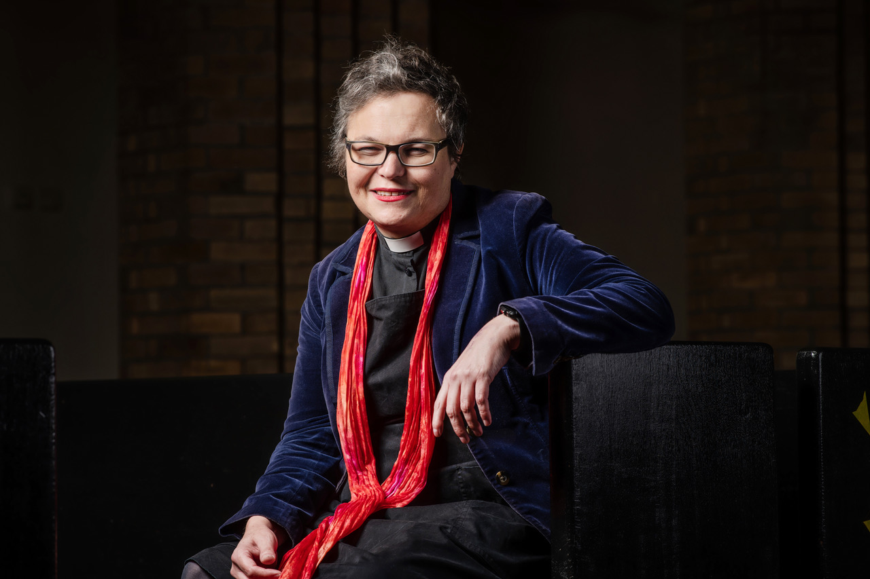

Candidate: The Rev’d Canon Dr Rachel Mann
Area Dean of Bury & Rossendale

Proposer: The Rev’d Dr Nick Bundock
Team Rector, St James and Emmanuel, Didsbury

Seconder: The Rev’d Grace Thomas
Curate, Moss Side, St James with St Clement, & Whalley Range, St Edmund

Contact: RachelMann@Manchester.Anglican.Org | 07834 403195

Who am I?
I was ordained in 2005 and have served my whole ministry in Manchester Diocese, firstly as curate at St Matthew’s, Stretford, and then at St Nicholas, Burnage. Since June 2021 I’ve been Area Dean of Bury and Rossendale. Prior to ordination I worked as an academic, a civil servant, and in church-related community work. At the turn of millennium, I lived in Salford and was Church Warden at St Ambrose, Langworthy. Between 2009 and 2017 I was Resident Poet at Manchester Cathedral and I’ve written twelve books on topics covering theology, poetry, literature, and cultural history. I am a member of the Church of England’s Faith and Order Commission and served on General Synod between 2018 & 2021. I am honorary Visiting Fellow in English and Creative Writing at Manchester Metropolitan University and Visiting Scholar at Sarum College. I hold a PhD on the Bible and Nineteenth Century Literature and I’ve written book chapters and articles about the future of the parish, Anglican-Islamic relations, and women’s ministry, among many other topics.

What Can I Offer?

An experienced but fresh voice on Synod … I was elected to Synod halfway through the last Quinquennium. I’ve gained a lot of experience since then, without losing my enthusiasm or freshness. On Synod, I’ve spoken in debates on matter of international concern (including on Nuclear Arms), as well as in favour of the Church’s emergent evangelism and mission strategies. I voted for ambitious climate targets for the C of E. I have sought to keep up pressure up on improvements to safeguarding and CDM matters, as well as trying to bring a generous, pragmatic and positive approach to matters of human sexuality and gender identity. I have voted in support of the ongoing simplification agenda in the Church of England.

An openness to change and evolution, with a love for local ministry … I am passionate about seeing the Church flourish and for people to come to know Jesus Christ. The parish is a gift and represents a most powerful focus for mission, but I also believe the Church needs to be open to new missional opportunities that will help parishes and local ministry flourish. I am excited by the Diocesan vision and the national church’s desire for a culture which celebrates a mixed ecology.

A passion for nurturing lay and ordained vocations … I’d like to continue to bring my parish and diocesan experience into General Synod at a time of profound change in training and formation. I’m a Vocations Adviser and Examining Chaplain and a Trustee of Emmanuel Theological College and have taught ordinands and lay leaders over many years. My experience means I can make an intelligent and informed contribution to discussions about the future direction of the Church.

An enthusiasm for evangelism and mission … I believe the C of E has a unique remit to speak into the life of the nation about the transforming love of Jesus Christ. I have a commitment to the Parish as a powerful focus for mission whilst believing that it is at its best when it evolves and meets emergent needs. I am passionate about working alongside lay and ordained people to discern new ways to serve community and share in God’s mission.

A commitment to mutual flourishing within the Church of England … One signal of my commitment to this is my involvement, over several years, in ‘Joint Chapter’ meetings between Women’s Chapter and The Society/Forward in Faith. Equally, while I identify as modern Catholic and am a member of the Society of Catholic Priests, I came to faith in an Evangelical-Charismatic setting and remain profoundly grateful for the formation I received there. As Area Dean of a richly diverse Deanery I am passionate about mutual flourishing as well as growth in our parishes and mission communities irrespective of tradition.

A desire for full inclusion of LGBT+ people in the life of the Church … The Church of England and General Synod continue to wrestle with matters of sexuality and gender identity. The LLF process continues to deepen and shape understanding across lines of difference. Whilst passionate about gracious and respectful disagreement, I hope my experience and personal story will bring richness and nuance to often stale debate and continue to make a small contribution to greater inclusion.

A prayerful commitment to celebrating all God’s people … The fundamental frame through which I seek to operate is prayerful attention to the abundant, gracious God. I am a spiritual director and have taught on the Diocesan course which forms new spiritual directors. I want to see all God’s people flourish and become who God is calling them to be. Drawing on my experience of being disabled, I have particular passion for creating fuller participation for disabled and chronically ill people in the structures and life of the church.

Ability to work creatively with structures … I am confident about working in committee and bureaucratic settings, having experience as both a Civil Servant as well as serving on Diocesan Synod, Bishop’s Council, Deanery Synod, and the Faith and Order Commission. However, I do not see them as ends in themselves; I am excited by the creative opportunities being revealed by the Spirit both locally and nationally through the structures we have.

I hope not only that would I bring ongoing energy, but offer commitment and focus as one of your clergy representatives. I would seek to bring your voice and concerns into General Synod. Please contact me if you wish to discuss anything I’ve said here or any other matters using the contact details given in this election address.
I ask you, prayerfully and carefully, to consider voting for me in this election and giving me, if possible, your first preference vote.
Thank you for reading.
Rachel

