The Revd Canon Lisa Battye

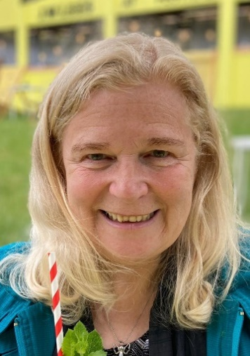
Proposed by

The Ven David Sharples
The Revd Nick Watson

Current clergy roles

Team Vicar (0.5) St James and Emmanuel, Didsbury 2017-
Chaplain, Emmanuel Theological College 2021-
Member of General Synod 2015-
Diocesan Synod 2009-
Mission and Ministry Committee 2019-
Canon of Manchester Cathedral 2016-

Previous clergy roles

Advisory Board/ Chaplain, St Mellitus College NW 2017-2021
Mission and Pastoral Committee/Bishop’s council 2010-2018
Area Dean for Salford 2012-2017
Rector, St Paul, Kersal and St Andrew, Carr Clough 2002-2017
Curate, Clifton, Salford 1999-2002
Mayor’s Chaplain 2000

Other experience

Married mother of four young adults; Early work in nursing, midwifery and health visiting (setting up a new Elderly Care service); Business Management (12 years); Fund-raising and project management; Property management; Street Pastors; CCJ (Council of Christians and Jews) and Interfaith work; Research degrees in Social and Pastoral Theology, Applied Practical Theology, and Trinitarian Ecclesiology; Co-leading five pilgrimages to Israel; Unite Faithworkers Branch Representatives’ Induction course; church links in Africa, USA and Finland.

General Synod

The work of General Synod is vital for the health of the Church. It is where our intentions are written into our rulebook, and this needs doing well.

In my first term of office I have played an active part in every group of sessions on those issues that directly affect parochial ministry as I have experienced it on the ground. In 2017 I was invited to serve on the Archbishops’ Task Group which led to the Covenant for Clergy Wellbeing. In 2018 I represented General Synod at that year’s Methodist Conference.
In February last year I became secretary for a popular new General Synod fringe group called ‘The Evangelical Forum’. This differs from the non-inclusive EGGS (Evangelical Group on General Synod) group by being open to all.

This year I have played a significant part in the successful challenge in July to the inadequate proposals for reform of the Clergy Disciplinary Measure.

What I will bring to the work of General Synod

If I am re-elected I will
- think independently and foster unity
- make sure General Synod knows what God is doing in Manchester
- seek to serve your interests well

I am standing for re-election in the belief that General Synod needs continuity as well as change, and that my work on it is not yet done. It takes years to become familiar with General Synod protocols, so I bring the potential to ‘hit the ground running’ to this election. I am passionate about sharing the gospel, and the integrity of the Church. I have a track record of bringing forward vocations to ministry of all kinds, and working with ordinands as their honorary Chaplain has caused me to care deeply about how they are equipped for our complex role. I am also fully on board with the ‘Setting God’s People Free’ agenda, and want to see it changing the way that General Synod operates.

My 18 years in Salford has ‘left its mark’, as does my current work in Didsbury, supporting our gifted rector, Nick Bundock. Our congregations are so diverse that I scrutinise every agenda from multiple perspectives. We serve a large group of Farsi-speaking asylum-seekers, an Academy Trust of four schools, and many who are part of us because (unusually for a church in the evangelical tradition) people identifying as LGBT+ play a full part in parish life at all levels.

Faith in the future
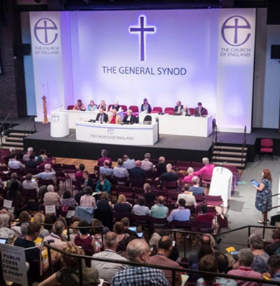
During this time of such enormous change I will bring ‘the gift of faith’ in the future of our denomination. I think that with God’s help we can make those ‘paradigm shifts’ that are needed for the work of local churches changing nations.

I believe that the Church of England needs to ‘save the parish’ and to change and evolve, as the Lord leads and the UK needs.

It seems clear to me as we approach COP26 that our most pressing concern must be to play a full part in the journey to net zero CO₂ emissions that has been charted in the recent Intergovernmental Panel on Climate Change report.

Meanwhile I will do my best to help us bring the big issues of our day to resolution, so that the energy that they have been consuming can be re-routed into the work of Christian mission and service.

I ask you to please give me your first preference vote.

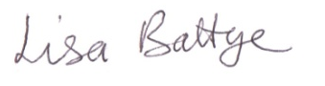

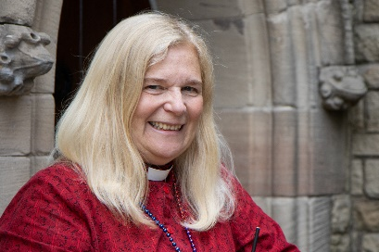
If you would like to discuss your views with me or ask for mine on any particular issue please get in touch: lisabattye@gmail.com 0161 434 9886 07539775483

