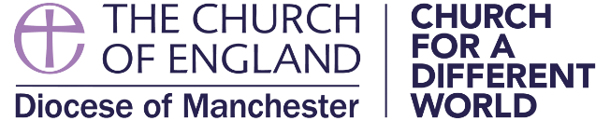

Curriculum Vitae
Name

Ordained Deacon
Year / Diocese

Ordained Priest
Year / Diocese

Current Post
Assistant Curate / Benefice / Brief Summary of Main Areas of Ministry

Further Education
Year / Qualification / Institution

Professional Qualifications
Year / Qualification / Institution

Employment before Ordination
From / To / Post / Employer

Offices or Responsibilities Held Since Ordination
From / To / Office / Brief Description
(eg. Chapter Clerk, Honorary Chaplaincies, Diocesan Committees, etc)

Continuing Ministerial Education and Development
Curses attended and development activities undertaken since ordination, e.g. mentoring, youth ministry. Include courses and activities both inside and outside the Church.)

Any Publications

Theological and Ecclesiological
(Which theological traditions have shaped your ministry and with which do you feel most at ease today?)

Responsibilities in the Community
(Please indicate your responsibilities in the community, e.g. school governor, political or community service)

Other Areas of Interest
(Please indicate any relevant special areas of concern, e.g. particular issues in contemporary life, international matters, academic or artistic interests)

Other Interests
(Please indicate other recreational interests)

