

Handbook for Curates and Training incumbents 2024 – 2025 (Part 3)
Appendices
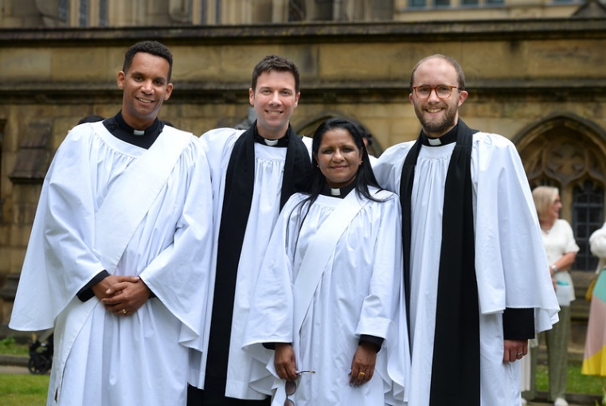
Head of Clergy Development
Revd Dr Daniel Mullaney
Tel: 0161 828 1452
danielmullaney@manchester.anglican.org

Handbook for Curates and Training Incumbents Part 3

Introduction
This section of the Curacy Handbook includes information and forms which will be useful during the curacy. They are designed to support curates as they progress through their curacy and to help them develop their skills as reflective ministers.

When completing an Appendix to be sent as an email attachment please download, complete and return just the relevant Appendix; do not return the whole Handbook as an attachment.

Appendix 1: Formational Qualities for Ordained Ministry (IME Phase 2) 3

Appendix 2: Curate Information and Contact Details 2024 - 25 5

Appendix 3: Ministry Development Journal 7

Appendix 4: ILG Case Study Feedback Form 9

Appendix 5: End of year ILG Tutor’s report 11

Appendix 6: Record of Supervision 13

Appendix 7: Sermon Feedback Sheet 15

Appendix 8: The Ministry and Training Agreement 18

Appendix 9: Curacy File Reference Form 22

Appendix 10: Guidance for Training Incumbents 23

Appendix 11: Training Incumbent’s Contact Details 27

Appendix 1: Formational Qualities for Ordained Priestly Ministry at IME 2

The single page document below summarises the qualities that curates are required to develop to enable the Bishop to decide that they have completed their curacy satisfactorily and so are able to move to an appointment as an incumbent or equivalent, (e.g. a chaplaincy post) either in Manchester or else where in the Church of England or the Anglican Communion.
A full description of the qualities summarised in this document and those for distinctive deacons and pioneer ministers can be found on the Church of England national website at:
https://www.churchofengland.org/resources/diocesan-resources/ministry/after-ordination
The framework clearly puts the focus on the development of these qualities rather than the attainment of a specific level of skill or academic achievement and, crucially, seeks to support curates as they inhabit ordained ministry confidently and develop the lifelong habits of prayer, study and learning that will underpin ministry in the years ahead. They do not demand an abstract level of attainment or a one-sided emphasis on ministerial practice, over against theological insight or personal devotion but rather seek to foster an integrated and developmental approach to ministry formation which is dynamic and seeks to support curates in their ongoing vocation. This means that the potential for future development can be recognised alongside the growth already observed during a curacy. They are based on the Ordination service and seek to integrate personal qualities, ministerial gifts and theological understanding. In practice there will clearly be significant overlap between the seven qualities and curates and training incumbents alike are urged to avoid repetition when it comes to writing appraisals. The key to unlocking this whole process is that it is just that – a process of growth where together, curate, training incumbent, and Diocesan staff - are looking for signs of that growth as the curate increasingly inhabits the qualities.

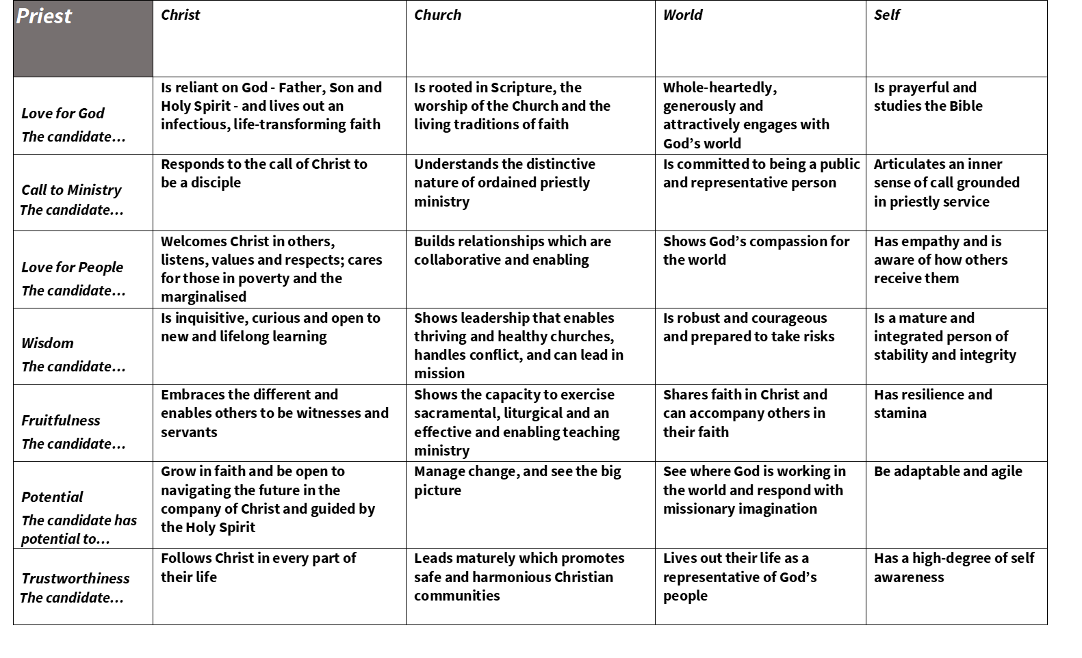

Appendix 2: Curate Information & Contact Details 2024 – 25
Information given on this form will be used by the HCD during your participation in the IME 2 Programme and for the purpose of creating a database of current curates. All information will be used in accordance with the Diocese of Manchester’s privacy notice which can be found at:
https://www.manchester.anglican.org/support-for-parishes/gdpr/privacy

Name ………………………………………………………………… Category OLM/ SSM/ SM/ MSE/ OPM

Parish/Benefice/Team/Other …………………………………………………………………………………..

Home Address …………………………………………………………………………………………………………………………

………………………………………………………………………………………………………………………………………………

Phone number: home……………………………………… mobile………………………………………………….

Email: …………………………………………………………………………………………..

Usual day(s) off …………………………………………………………………………………….

Dietary requirments?........................................................................................

Any other requirements or information you would like the HCD to know? E.g. mobility, dyslexia, learning differences, disability.
…………………………………...............................................................................................

Sending parish (Church you attended when sponsored for IME 1)
…………………………………………………………………………………..…………………………………………………………….

Placement parish during IME 1 (if applicable) ……..…………………………………………………………….

Safeguarding
Please record the date of your most recent safeguarding training, the modules included and the training provider and location.

Date of training | Modules | Training Provider | Location

Theological Training
Name of College or Course attended in IME 1 | Dates attended | Qualification awarded or still to be completed
Prior training or experience e.g. professional, apprenticeship, university Bible College, Mission Organisation | Dates attended | Qualification awarded or still to be completed

Other information
Please give brief details of other relevant information you think it would be helpful for the HCD to know.
. . . . . . . . . . . . . . . . . . . . . . . . . . . . . . . . . . . . . . . . . . . . . . . . . . . . . . . . . . . . . . .

. . . . . . . . . . . . . . . . . . . . . . . . . . . . . . . . . . . . . . . . . . . . . . . . . . . . . . . . . . . . . . .

Please complete this permission to indicate that you do or do not agree that your email and phone number can be used for IME 2 purposes:
I agree / do not agree that my email address and phone number can be shared with members of the IME 4 – 6 cohorts, my ILG Tutor and Diocesan Staff who may need to contact me for IME or other purposes connected with my appointment as a curate.
I agree / do not agree that my mobile phone number may be added to a group contact list for WhatsApp messaging.

Please return the form as an email attachment to:

JonathanBramwell@manchester.anglican.org
Appendix 3: Ministry Development Journal – Capturing Learning from a Ministry Event
The form below is designed to help you reflect systematically on your experience of ministry in order to help integrate learning and practice. It can be used when planning a presentation to your ILG and adapted to your own needs.
Not all the questions will be relevant for every situation. This template is based on the model of ‘Progressive Theological Reflection’ outlined in Judith Thompson, SCM Guide to Theological Reflection. (London: SCM 2008, p 55-56).
Ministry Development Journal pro forma
Date & time:
Experience: what was the event which you are working with?
Date / time: Location:
Nature of event:

Describe briefly what happened:

Describe your own role:

How did you feel about the event / your role within it?

Explore: what were the main issues / questions which this event raised?

Reflect: building a theological understanding
What insights from the faith tradition (e.g. from Scripture, theological writing, historic tradition) help to build a theological understanding of what happened?
Now return to the original situation
How do these perspectives change your initial understanding of the situation?
Respond: how might you change your response to this experience?
What are the implications for future practice? What specifically might you do differently in a similar situation, and why? Is there anything you need to do now?

Any other questions to note or follow up?
Books / resources to note
This relates to the following Learning Outcomes:

APPENDIX 4: Intentional Learning Group Case Study Feedback
Curate |  | Tutor
Cohort |  | Category of ministry | OLM/SSM/SM/ Pioneer
Case Study Topic
Date of Presentation |  | Date of Feedback
Summary of Feedback

Learning Towards (Formational qualities)

Experience – how well was the experience described, including their own reaction to it?

Exploration – how well did they understand and explore the issues raised by the presentation topic?

Reflection – how well did they bring theological insights to bear on the case study?

Response – what new insights did they gain from the case study, reflection and group discussion?

Presentation skills - how well did they present the case study?
How well did they engage with the group, respond to questions and handle differences?

Areas for further development for their next ILG presentation

For the curate’s use following the ILG meeting
What new insights into the situation or action points did I gain from the group?
How can I develop my skills when I prepare for my next ILG presentation?

APPENDIX 5: Intentional Learning Group End of Year Report
Name of Curate Name of Tutor
Date Category of ministry: SSM/OLM/SM/OPM
Summary

How well did the curate engaged with the process of peer learning and theological reflection in the group?

Please comment on the curate’s development as a reflective practitioner and how well they integrated theological insights into their own practice

Please comment on the curate’s self-awareness and their ability to relate to others in the group, including those with whom they disagreed

Please highlight any areas for further development

Appendix 6: Record of supervision
This form is designed to enable the training incumbent to make a brief record of regular supervision meetings. The completed record should be copied to the curate promptly for her/him to add their own comments and will become part of their Ministry File and, if they wish, refer to it in their self-appraisals.
Using the template will help the supervision become more focused and purposeful but please feel free to adapt and customise the form to suit your particular needs and preferences.
Curate |  | Supervising incumbent
Date of supervision:
Review of significant learning experiences from the previous supervision
General review of curate’s ministry
Main topic covered during this session
Record of decisions taken, who will implement them and by when
Actions / agenda for next supervision meeting

Curate’s notes / reflection

APPENDIX 7: Sermon Feedback and Review Sheet
Thank you for taking time to fill in this form. It’s always helpful for preachers to know how their sermons are received and it will be most useful if you can fill in this form as soon after hearing the sermon as possible. We know you will fill it in with the best interest of the curate in mind. It would also be helpful if you include ways in which you think that they could develop their preaching.
Name of curate
Date of sermon Bible readings
Type of service (e.g. Holy Communion/Service of the Word/All Age/Parade service)

A Theme and content
- How well did the sermon fit in with the service as a whole?

- How did the sermon relate to the Bible readings?

- In one sentence, write down the main theme of the sermon.
How clear was the theme?

- In one sentence write down what the sermon was asking/encouraging you to do in response?

- How appropriate was the sermon to the context and congregation?

- Did the preacher use any parables or other stories?

If so, were they appropriate to the context and the theme of the sermon?
- If the preacher used humour how appropriate and effective was it?

B Structure
- How did the sermon begin?

Was it appropriate for the content of the sermon? Too short? Too long?

- Was the sermon coherent and keep to its theme or did it wander off the theme?
- How did the sermon end?

Was it effective as a conclusion to the sermon?

C Engagement
- How did they engage you intellectually and emotionally in what they were saying?

- How far did you feel they were personally involved in what they were saying?

- In what ways did the sermon inform, challenge or surprise you?

D Communication and body language
- Was the sermon a) too long b) too short c) about right

If it was too long or too short why was this the case?

- What sort of language did the preacher use:
Was it easy to understand?
Did they use short, clear sentences?
Were academic/jargon words used?
Was it abstract/theoretical or down to earth?
Was it inclusive?
Was it difficult to understand at any point? e.g. obscure, long sentences

- How did the preacher use her or his voice:
Could you hear easily or were they too quiet?
Did they shout?
Did they sound enthusiastic or bored?
Did they vary their volume and tone of voice?
- Did they speak a) too quickly b) about right c) too slowly

How far did they vary their speed of delivery?

- How did the preacher use their body? (e.g. did they remain still, walk around or use any distracting movements?)

- How well did the preacher make eye contact? (e.g. did they look at their notes all the time/did they look at the people from time to time?)

- In what ways do you think that the preacher could develop their skills in preaching?

Appendix 8: Ministry and Training Agreement July 2024 – June 2025
for Training Incumbents and Curates
Curate ……………………………………………………. Parish & Mission Community …………………….
Training Incumbent …………………………….…. Category of ministry SM/SSM/OLM/MSE
The form should be kept available and referred back to regularly. It may need to be amended by mutual agreement. Please expand the boxes as necessary. Please send a copy of the Agreement to the HCD, Rev Jonathan Bramwell, JonathanBramwell@manchester.anglican.org) by September 30th 2024.

Ministry Framework | Curate | Incumbent
Pattern of Sunday worship
Leading Sunday worship (frequency)
Preaching (frequency)
Attendance when without specific role
Midweek worship
Other
Day(s) off (free from parish, IME or other ministry commitments)

Prayer together | Curate | Incumbent
Usual pattern of prayer together
Attendance at Meetings | Curate | Incumbent
PCC/DCC Meetings
Church Committees/Groups
Chapter and Deanery Synod
Churches Together, Interfaith groups or equivalent
Other commitments
Quiet days, retreat, spiritual director
Dedicated time for personal study
IME Phase 2 programme (Including ILG)
Annual leave including five Sundays
1
2
3
4
Curate’s main areas of work and/or responsibility
Main areas of responsibility in Church e.g. pastoral visiting team, Mission Action Plan, Messy Church (It is not expected that these will all be decided at the start of the curacy.)
Specific commitments within the community. E.g. schools, community groups, residential homes (It is not expected that these will all be decided at the start of the curacy.)
Staff / Ministry Team Meetings
Frequency:
Venue:

Office space
What office space will the Curate have?

Clerical dress
What is normal liturgical dress?
What other expectations are there regarding dress code?

Expenses
Reference should be made to Parochial Expenses of the Clergy 2017 which gives guidance on expenses. Available online at: https://tinyurl.com/y9sn587j

How will the Curate claim expenses, how frequently and from whom?
What can the Curate claim for?

Communication
What agreed expectations are there regarding the use of email and phone? What clergy contact details will be publically available?

Social Media
Whilst the use of social media can have huge benefits in ministry there are also potential drawbacks and some significant hazards to avoid. Please read the Diocesan guidelines on the use of social media available here:
https://www.manchester.anglican.org/document?search=Social+media&sort=title-asc
and the national Church of England guidelines available here:
https://www.churchofengland.org/terms-and-conditions/our-social-media-community-guidelines
How will parish social media accounts be used and what rules will apply to personal (but never private) accounts?

Supervisions (not less than 9x a year for full-time stipendiary curates; not less than 6x a year for others)
In the first year of a curacy supervisions for stipendiary curates should include, among others, the following topics: the transition to ordained ministry; public ministry & The Guidelines for the Professional Conduct of the Clergy; conducting worship and preaching; preparing for ordination; administration, communication and time management. For self-supporting curates some of these topics should be included in supervisions.
Date | Time | Venue | Specific topic
1
2
3
4
5
6
7
8
9
10

Safeguarding
Please record the date of your most recent safeguarding Leadership Module training and the training provider and location.

Date of training  dd/mm/yy | Leadership Module | Training Provider | Location

Notes
- Under their training incumbent’s supervision curates need to come to an agreement with them regarding their ministry, learning and development during curacy. This document is designed to enable open and productive conversations between clergy colleagues and to encourage mutual accountability. It is intended to support a working relationship, manage expectations, check assumptions and anticipate areas of tension or role conflict. Please use it flexibly to suit your context, the requirements of the parish and the training needs of the curate. It should be a key reference point throughout the curacy and should be reviewed at least annually and a copy sent to the HCD each year.
- The Ministry and Training Agreement is not a contract and complements the more generic Statement of Particulars of Office.
3. All curates should agree holidays, working hours and time off with their Incumbent. Stipendiary clergy have an annual holiday leave entitlement of thirty-six days including five Sundays and should have a rest period of at least 24 hours each week. In addition, 8 days may be taken as Bank Holidays or in lieu of Bank Holidays. The holiday year begins on 1st February. The situation for self-supporting clergy is more varied and should be mutually agreed with their Training Incumbent and discussed with the HCD. There is no standard pattern for SSM/OLM clergy.
4. Additional day off each month. ‘The recommendation from the Bishop is that clergy should have one full day off per week, with an additional day off once a month so that two consecutive days are taken, and clergy are strongly advised to take this time off.’ Guidance for Ecclesiastical Office Holder, 2022.
This additional day must be agreed with the training incumbent and may need to be varied according to the requirements of parish ministry, e.g. during Holy Week, at Christmas or to fit in with other priorities.

Privacy Statement:
Information gathered on this form will be used in strict accordance with the Diocesan Privacy Policy. Full details of the policy can be found at:
https://www.manchester.anglican.org/support-for-parishes/gdpr/privacy

Appendix 9: Curacy File Reference Form
This form is designed for use in the final assessment process to enable you to receive brief references from a range of people (lay or ordained) who have experience of your ministry and/or of working with you. It will provide evidence of your gifts as a minister, encouragement and insights into how you may continue to develop in ministry. Please let those you ask know that you will include the form in your Curacy File to be submitted to the HCD as a part of your final assessment to the Bishop and that the information they provide will be confidential to the Bishop and you.

Name of Curate

Area(s) to be commented on (to be identified by curate)

Name of referee Organisation

Role/Position/ Job Title How long have you known me?

Brief description of the context in which we have known each other

What do you see as my strengths and gifts and how have you seen them develop during my curacy?

Which of my skills do you think are transferrable to other areas of ministry?

How do you think my skills might be further developed?

Any other comments that would be helpful for my development as a minister?

Signed ……………………………………………………………… Date ……………………………..

Appendix 10: Guidance for Training Incumbents

Introduction
Training incumbents are called, under the authority of the Bishop, to be responsible for preparing the newly ordained for fruitful and resilient ministry in God’s Church. The work and ministry of a training incumbent is recognised as being highly significant for the mission of the church and the proclamation of the Gospel. They will, therefore, be clergy with the necessary experience, gifts and character and who are committed to collaborative ministry, continuing ministerial development and participation in the Deanery and Diocese. They will understand the importance of giving time to the supervision and training of a curate, of praying with them regularly and of reflecting theologically with them throughout their curacy. This is a demanding responsibility and requires a significant amount of time. Having a curate should never be seen as acquiring ‘an extra pair of hands’ but as an opportunity to work with a colleague in the service of the Church and the Kingdom of God which is a privilege and a joy. The relationship between training incumbent and curate is one between adults who each have specific but different responsibilities, and a variety of gifts.

The context
Ordained ministry is continuing to change in its outward activities, priorities and demands. In Manchester the advent of new, larger Deaneries and Mission Communities means that to some extent clergy will need to understand their vocation differently from in the past. Training incumbents will need to be flexible and able to show resilience at a time of change and work carefully with curates as they navigate both the changes which accompany beginning ordained ministry and the challenges and opportunities which Diocesan reorganisation will bring. Having said which, the heart of ordained ministry remains unchanged – the prayerful and faithful ministry of word and sacrament, pastoral care of Christ’s flock and leadership in mission in all its many dimensions. For the great majority of curates in our Diocese this will be in the context of parish churches within a mission community but may also be in other forms of ministry such as chaplaincy and church plants. This will usually be for a three-year period, beginning at Petertide in the year of ordination as deacon.

The effective training of curates depends on a four-way partnership between
the bishop and Director of Vocations  the training incumbent  the curate `  the HCD | 

It is vital that there is good communication between all four to enable training to be as rich and formative as possible.

The Role of the Training Incumbent
Training incumbents will commit to working fully within the Diocesan guidelines and provision for Initial Ministerial Education Phase 2 and the Church of England’s national framework for IME 2

The training incumbent’s role includes:

- taking into account the curate’s prior experience (ministerial, professional and personal)
- ensuring a pattern of regular prayer together in accordance with the Bishop’s guidance
- ensuring that the curate gains a broad range of ministerial experience that will prepare them for future ministry, whether stipendiary or self-supporting. This should include experience across the mission community
- working collaboratively including in planning and decision-making
- regular times of supervision and theological reflection with the curate which are given priority in the diary
- completing a Ministry and Training Agreement each year and sending it to the HCD
- ensuring that the curate gives priority to the requirements of the IME 2 programme, working in partnership with the cohort Bishop and the Bishop’s officers. The national recommendation is for 15% of ministry time to be devoted to further study and the IME 2 programme
- providing good, timely feedback on ministry, including both encouragement and challenge, and, if necessary, raising any concerns with the curate in an appropriate and timely way
- providing thorough appraisals at IME 4, IME 5 and the end of curacy
- keeping a good balance between active ministry and the need for reflection and refreshment
- demonstrating a high level of engagement with Diocesan and Deanery activities and expectations, especially in the formation and leadership of mission communities
- working with the curate to ensure their wellbeing
- providing, negotiating and ensuring appropriate boundaries, ministerial practices and frameworks for confidentiality, safeguarding and resilience with the curate
- communicating to Churchwardens and PCC, and more generally in the congregation and parish, that a curacy is a time-limited training post
- undertaking further study and on-going training specific to their role including the Diocesan provision for the training and support of training
incumbents. New training incumbents will be mentored by an experienced colleague in their curate’s first year in post.

Personal Qualities and Gifts
Training incumbents will:

- be people of prayer, mature faith, humility and wise self-awareness
- have a deep awareness of the call and grace of God in their own lives, and recognise the privilege of serving the Church and Christ in the world
- understand the significance of their role and personality on the curate’s formation for ministry, including being aware of the power imbalance inherent in the training incumbent-curate relationship
- be committed to empower and enable colleagues to grow and flourish as priests and to allow them to develop in ways different from their own
- model strategic and reflective, theological leadership
- be willing to devote the time, energy and expertise necessary to offer effective and fruitful training, with the flexibility to take into account the curate’s experience and specific circumstances
- have the ability to help the curate in the process of integrating their theological studies with ministerial experience
- be able to interpret the social dynamics of the parish and mission community and to develop a strategy for mission
- be open and collaborative in discussion, planning and decisions in the parish whilst also exercising due authority as incumbent with humility
- communicate expectations and guidance clearly and in good time
- have a passion for developing lay and ordained ministers of the gospel, and for the mission of Christ’s Church in the world
- be willing and able to let go of responsibility to others, whilst offering training, support and supervision
- share of themselves with colleagues, including difficulties and disappointments, and be willing to learn from and with them
- be self-aware, secure but not defended, vulnerable but not fragile
- engage regularly in continuing ministerial development and take time for reading and study
- model good practice in personal wellbeing and ministry practice, including time off, holidays and, where appropriate, family boundaries
- know their limitations and be able to rejoice in and rely on others’ gifts
- be committed to remaining in post for a minimum of eighteen months from the start of the curacy

The Parish / Mission Community Commitment
The parish / mission community will:

- be committed to the Diocesan strategy to be a Church for a Different World through being a growing, nurturing and serving Church and demonstrate a high level of engagement with Diocesan and Deanery activities and expectations
- have a current and working Mission Action Plan
- endeavour to pay parish share in full
- be seeking to promote and develop lay and ordained vocations, and will be a community where whole life Discipleship is taken seriously
- be committed to the full inclusion in ministry of those of UKME heritage and those with disabilities
- recognise that the curate is primarily appointed to a training post under the supervision of the training incumbent
- pay the curate’s expenses of office in full

May 2022

Appendix 11: Training Incumbent’s Contact Details

IME Phase 2. Training Incumbent’s Contact Details 2024 - 25

Name …………………………………………………………………

Parish/Benefice/Team …………………………………………………………………………………………………………..

Does the parish come under alternative episcopal oversight? ……………………………………………

Mission Community ………………………………………………… Deanery …………………………………………

Phone number: home………………………………………… Mobile………………………………………………

Email: …………………………………………………………………………………………..

Usual day(s) off …………………………………………………………………………………….

Dietary requirements: …………………………………………………………………

Revd Dr Daniel Mullaney
Head of Clergy Development
Tel: 0161 828 1452
danielmullaney@manchester.anglican.org
All information will be used in accordance with the Diocese of Manchester’s privacy notice which can be found at:
https://www.manchester.anglican.org/privacy-notice/

