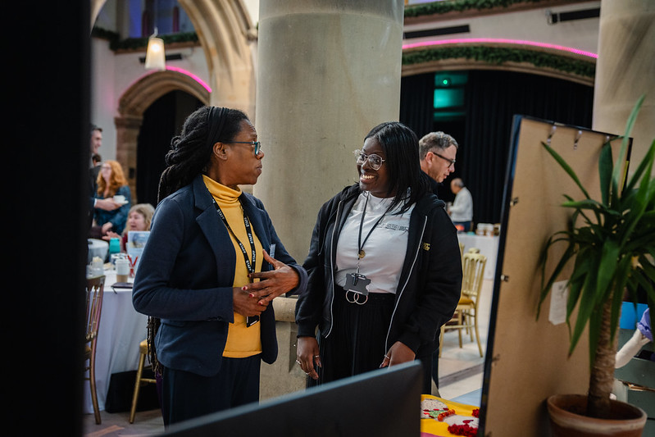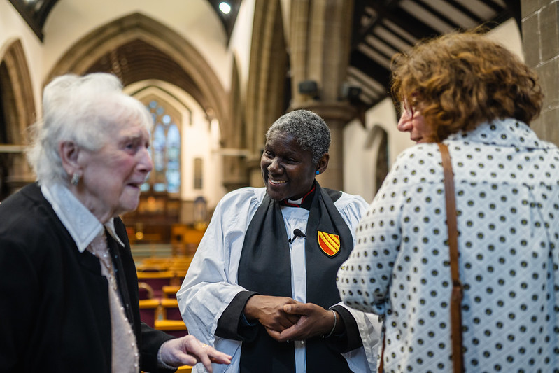
Racial Justice Grants
Guidance for Applicants
Funding is available to support initiatives and projects which will actively support diverse ministry and racial equality in churches across the Diocese of Manchester. The funding is provided by the Church of England’s Racial Justice Unit, in partnership with the diocese.
The funding is to enable churches in the diocese to be able to support racial justice via ministry projects, new activities or written/physical resources. This is part of our initial three-year Racial Justice Programme, as well as supporting the wider delivery of our long-term growth strategy of Growing Younger, Church Planting and Revitalisation, Developing Missional Leaders and Parish Renewal. If the funding is to be used for any capital expenditure items, a clear justification as to how this will support revitalisation and future growth is needed.
It is recommended that before applying for funding that you engage with your local Deanery Transformation Support Officer (DTSO). They can provide support and advice with your proposal and application. They can also provide signposting to alternative funding sources if this fund may not be the most appropriate for your initiative/proposal at this time. Your application will need to be supported by your Area Dean and Mission Community Leader to be considered. This funding can also be used to support any other grant applications match-funding requirements. Currently funding applications can be received up to 2028.
To support parishes in delivering racial justice initiatives safely and sustainably, guidance and advice are available throughout the planning and delivery of your project. Projects must meet diocesan and national safeguarding standards, including clear reporting pathways and appropriate supervision for all activities involving children, young people, or vulnerable adults. Applicants are encouraged to seek support from the safeguarding team at any stage to ensure that all safeguarding considerations are fully addressed and appropriate measures are in place.
As part of our commitment to transparency and good governance, all grant applications must be discussed with the PCC prior to submission. This ensures that the application has the backing of the parish’s trustees, provides an essential record of oversight, and demonstrates the shared support and accountability of parish leadership.
Please return initial applications to the Racial Justice Lead, Diane Gray-Stephenson. She will then contact you to arrange a meeting to discuss your application and hear more about your project.
Following this, and any relevant updates completed, your application will be reviewed by the grants Racial Justice Funding Steering Group and then taken to the relevant Board(s). You will then be notified of the outcome after the meeting. Funding is subject to a formal agreement between the PCC and the Diocesan Board of Finance.

The upcoming deadlines for applications are:

· Final applications – 10am on Friday 27th March 2026.
· Decisions made on Monday 13th April 2026

· Final applications – 10am on Friday 5th June 2026.
· Decisions made on Monday 22nd June 2026

· Final applications – 10am on Friday 7th August 2026.
· Decisions made on Monday 25th August 2026

Please note that the outline proposal deadlines are indications only. You are strongly advised to submit your outline well ahead of these dates to enable more time for the Racial Justice lead to review your proposal.

It is expected that those who apply for a grant will complete the follow up surveys at 1 and 6 months and provided feedback.

Contact Details for DTSOs:-
Deanery | DTSO | Contact Details
Bolton | Ima Lomax | imalomax@manchester.anglican.org  07467 719031
Bury & Rossendale | Ima Lomax | imalomax@manchester.anglican.org  07467 719031
Salford & Leigh | Sue Brown | suebrown@manchester.anglican.org  07908 663 614
Rochdale | Sue Brown | suebrown@manchester.anglican.org  07908 663 614
Oldham & Ashton | John Evans | johnevans@manchester.anglican.org  07769 377226
Manchester North & East | Andy Yates | andrewyates@manchester.anglican.org  07769380498
Manchester South & Stretford | Zoe Kruger | zoekruger@manchester.anglican.org  07769 380189
Diane Gray-Stephenson
Racial Justice Programme Lead
Dianegray-stephenson@manchester.anglican.org
T: 0161 828 1441
M: 07483194387

Racial Justice Programme Parish Funding Application
Date:
Church/Parish:
Contact:
Average All Age Weekly Attendance:
Initiative/Project Title:
Overview of Proposed initiative/project: (300 words max):
Funding Requested (up to £3000 per church): Breakdown to show what the funds are paying for (e.g. £100 refreshments, £200 venue hire etc.)

How will the funding help the church to advance racial justice in the parish? (300 words max):

Diocese Strategy - Outputs and Outcomes supported (please tick all that apply):
Outcomes & Outputs (2030 Goals as per Diocese Strategy) |  | Tick
Growing Younger | Increase in average weekly attendance of those under 18
Growing Younger | Increasing diversity of under 18s attending church weekly.
Growing Younger | Increase number of activity in parishes aimed at under 18s
Church Planting & Revitalisation | Provision of materials/resources for multicultural mission in parishes
Church Planting & Revitalisation | Increase new Anglican multicultural congregations/Christian gatherings within parishes
Parish Renewal | Increase in people attending church - All Age Total Average Weekly Attendance
Parish Renewal | Increase diversity of people attending church weekly - All Age Total Average Weekly Attendance
Parish Renewal | Increase people attending church in the 10% most deprived areas - All Age Total Average Weekly Attendance
Parish Renewal | A commitment to Racial justice Sunday
Developing Missional Leaders | Empowering clergy and laity to minister and lead in their local contexts.
Developing Missional Leaders | Provide learning opportunities to clergy and laity

Please provide any details of how these activities will be supported by the parish/congregation? (300 words max):

How will the initiative/project delivery be managed? (200 words max)

If the initiative/project requires purchasing items or services, how would this be done? (200 words max)

Please confirm that your respective PCC (minutes), Area Dean, and Mission Community Leader support this application. Yes / No

Once completed, please return it to Diane Gray-Stephenson. Dianegray-stephenson@manchester.anglican.org

