

My RIPPLE
reflection journal



Name:

Recognise
Which value are we focussing on?


What does the Bible story tell us about this value?
What does this Christian value mean?
I - me
Is this Christian Value a strength of mine?

People


Write about someone who shows this value.

Partner
How can I act to improve the lives of others?

Who is showing me this value in the world today?

Lead
How can I be a role model and display this value?



Equip
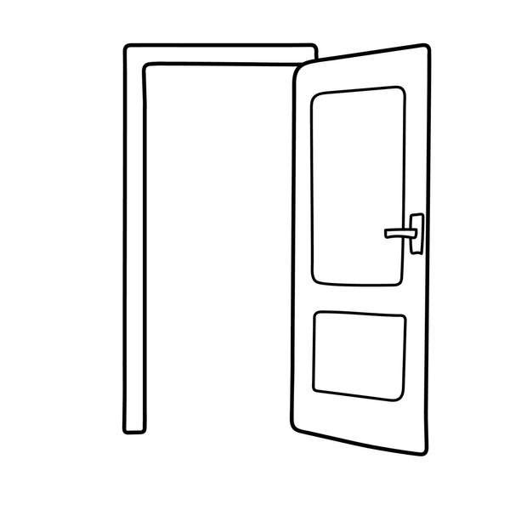
When I walk out of the door, what will I do differently?

